TPS and Alignment

All scripts are in the same directory as this document (V10__Create.sql , V10.1__Insert_First.sql, V10.2__Insert_second.sql, sql_generate.php, test1.sql, test2.sql)  
  
pgbench -T 300 -c 50:

first: latency = 31146.035 ms tps = 1.605353 file - test1.sql

second: latency = 33590.671 ms tps = 1.488519 file - test2.sql  
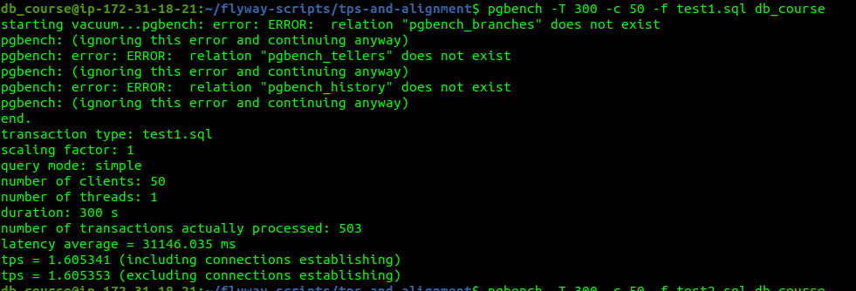  
  
graphic of latency for both tables:  
